File: ltuvi_timing.doc
Last updated: 28 July 2008

Timing of the ALICE TTC partition - LTUvi version

Table of contents
1 Introduction 1
2 General comments 2
2.1 Phase of the TTCrx BC clock 2
2.2 Phase of the L0 in "L0 over TTC" option 2
2.3 Phase of the L0 in "L0 over cable" option 2
2.4 Identical timing in both Global and Stand-alone modes - harmonisation 2
3 Synchronisation of the LTU - setting of the BC_DELAY_ADD register 3
4 Setting of the ORBIT_BC register 5
5 Setting of the Prepulse lead time T_{ppl0} - PP_TIME register 6
6 Correction of the Mini ID mismatch - ORBIT_TIME register 8
7 TTCex interface - BC_DELAY_ADD and TTC_INTERFACE registers 9
8 Definition of the L1 time (T_{L1}) - setting of the L1_DELAY register 14
9 Definition of the L1-to-L2 time (T_{L1L2}) - setting of the L2_DELAY register 17
10 Current setting of essential LTU timing-control words 18
References 18

1 Introduction
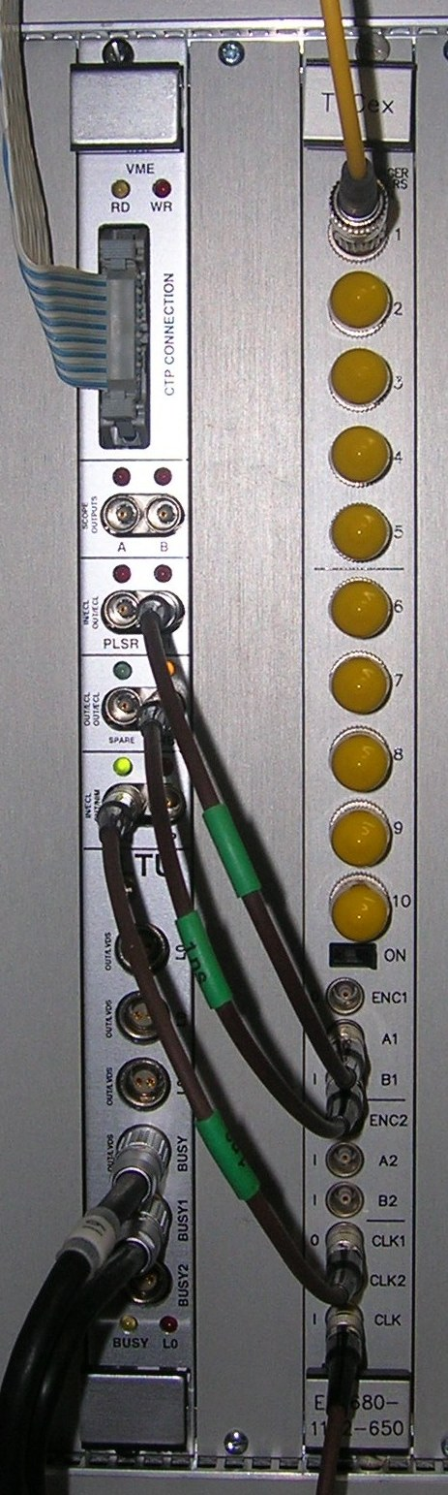
This document provides the mandatory rules for setting the timing in sub-detector TTC partition of the ALICE trigger system; the details of timing requirements and the setting procedures are explained elsewhere ([1], section 3.14). The note contains formulae, definitions, comments, a number of examples, etc.
In normal operation, the correct timing of the TTC partitions shall be set automatically by the trigger system control software. In Stand-alone mode, for testing purposes, sub-detectors might decide to make their own timing adjustments; even then, the requirements explained in [1] and the rules set in this document must be followed in order to avoid intermittent errors.
Current configuration of the ALICE TTC partition consists of the LTUvi board [1][2][3] and the TTCex opto-transmitter [4]; the connections within the partition are shown in [3], Figure B; a photograph in Figure 1.1 depicts a typical layout. The original configuration - that used to include the TTCvi board - is now considered obsolete and it is no longer supported.
Figure 1.1 A typical layout of the ALICE TTC partition

2 General comments

2.1 Phase of the TTCrx BC clock
The phase of the BC clock at the output of the TTCrx chip (Clock40, Clock40Des1, Clock40Des2) is locked to the TTCex clock; the phase is not affected by the timing of either the CTP (BC_DELAY on the BUSY board) or the LTU (BC_DELAY_ADD).

2.2 Phase of the L0 in "L0 over TTC" option
In case of the "L0 over TTC" option [5], both time-critical signals L0 and L1 are transmitted over the TTC Channel A; the phase of both signal - at the output of the TTCrx chip, in respect to the local BC clock - is "stable": it is always phase-locked to the TTCex clock and not affected by the timing of either CTP or the LTU.
Note: On the other hand, a change of the CTP timing could affect - and probably will - the Event -to-L0 delay; just a reminder…

2.3 Phase of the L0 in "L0 over cable" option
In case of the "L0 over cable" option, the phase of the L0 signal at sub-detector's front-end in respect to the local clock (always locked to the TTCex clock, see section 2.1) depends on the CTP timing in Global mode and the LTU timing in Stand-alone mode.
A possibility to change the phase/to delay the CTP's BC clock is required in order to be able to "track" the last arriving L0 input and, by doing so, to minimise the L0 latency. Such changes are going to be infrequent, always announced in advance, with enough time left to sub-detectors to "tune" their electronics. Sub-detectors that use the "L0 over cable" option must be able to "re-tune" to the modified L0 phase without physical access to their front-end electronics; the obvious options are the front-end reconfiguration, a change of programmable settings, etc.

2.4 Identical timing in both Global and Stand-alone modes - harmonisation
The LTU must ensure that the timing of trigger sequences as seen by sub-detector's front-end electronics in Stand-alone mode is identical to the timing used in the Global mode; in order to achieve that, the LTU's time-settings must always be harmonised with a current time-setting of the CTP. A term harmonised shall be often used in the following text; always with the same meaning: the LTU time setting that reproduces in Stand-alone mode the timing set by the CTP in Global mode.
The timing of trigger sequences in Stand-alone mode is defined by the setting of the L1_DELAY, L2_DELAY and the ORBIT_BC control words; their content, on the other hand, has no effect on the timing in Global mode.
The words BC_DELAY_ADD, TTC_INTERFACE, ORBIT_BC, ORBIT_TIME and PP_TIME affect the operation in both Global and Stand-alone modes; with a correct setting - a harmonised setting - they produce identical results in both modes.

3 Synchronisation of the LTU - setting of the BC_DELAY_ADD register
The LTU synchronisation procedure measures the phase (time of transition) of the signals generated by the CTP and clocked by the CTP's BC clock, in respect to the LTU's BC clock. The measurement provides the Transition Time (T_{tr}) - the BC_DELAY_ADD content at which the delay plot obtains the minimum value. A typical plot is shown in Figure 3.1; the corresponding value of the T_{tr} is 24.
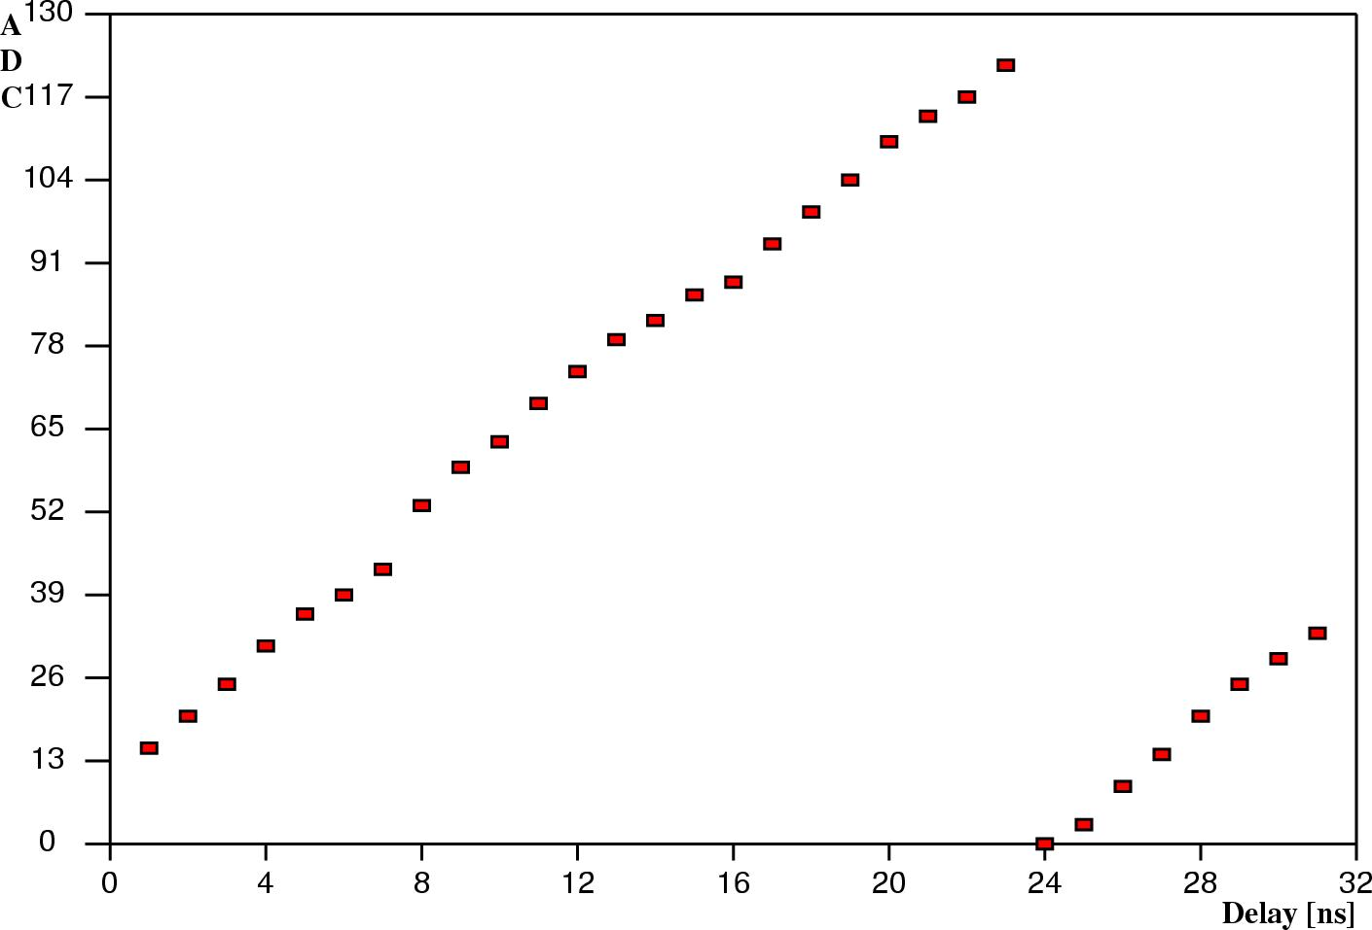
Figure 3.1 Typical plot of the LTU synchronization measurement; T_{tr} is 24
In Global mode, the CTP signals are sampled on the LTU board with a negative edge of the LTU's BC clock. The clock is generated on the TTCex board and delayed, on the LTU board, by a number of ns equal to the content of BC_DELAY_ADD register (0 to 31). When the register content is T_{tr}, the negative edge of the clock samples the input signal at, approximately, the middle of the pulse, with a maximum and symmetric safety margin (~ ± ½BC).
In Global mode, the L0 signal that appears at the LTU front panel output is not affected by any LTU setting - it is just the original CTP signal re-transmitted; its phase is set by the working content of the BC_DELAY register on the BUSY board. In order to achieve the same phase of the L0 output in Stand-alone mode - when the signal is generated by the CTP emulator logic on the LTU board - the content of the BC_DELAY_ADD register must be set according to the following formula:
[BC_DELAY_ADD] = (T_{tr} - 2)_{modulo 25} [3.1]
Examples: For T_{tr} = 17, [BC_DELAY_ADD] = 15; for T_{tr} = 1, [BC_DELAY_ADD] = 24; for T_{tr} = 0, [BC_DELAY_ADD] = 23; etc.

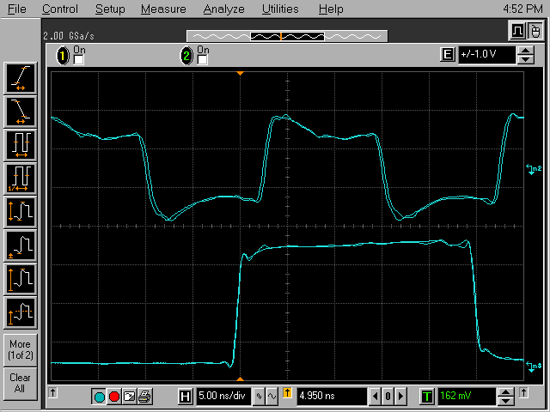
Figure 3.1 Identical phase of the L0 output in Global and Stand-alone modes
Trace m1, m2: CLK1(O), TTCex board (ECL, AC coupling; scope-probe connection)
Trace m3, m4: L0 output, LTU board (ScopeProbe channel B, selection code 4)

Verification: Figure 3.1 depicts the phase of the L0 output (trace m3 - Global mode; trace m4 - Stand-alone mode) in respect to the TTCex clock (trace m1 - Global mode; trace m2 - Stand-alone mode), with the BC delay set using Formula 3.1 - the phase shift is hardly noticeable. The signals have been generated using the test CTP in the Trigger Lab at CERN, in the TTC partition code-named "HMPID": the L0 signal has been taken from the ScopeProbe channel B, selection code 4; the TTCex BC clock has been connected to the TTCex CLK1 output, using the "Y" adapter and a scope-probe, the synchronisation has given T_{tr} = 26; the corresponding setting for the BC delay has been [BC_DELAY_ADD] = 24.
Very similar waveforms have been observed in the test "MUON" partition with T_{tr} = 26 and for [BC_DELAY_ADD] = 24.
Mandatory Rule 3.1:
For any change of the CTP timing (a change of the BC_DELAY content - BUSY board; a change of the BC input cable - BUSY board; a change of the CTP to LTU cable; etc.), perform the LTU synchronisation, find a new value of the T_{tr} and then set the [BC_DELAY_ADD] according to Formula 3.1.

4 Setting of the ORBIT_BC register
When the setting of ORBIT_BC register (on the LTU board) is harmonised with the BC_OFFSET setting (on the L0 board), the lead time of the Prepulse in respect to the calibration trigger L0 (PP_TIME setting) and the Mini ID mismatch correction (ORBIT_TIME setting) remain the same in both Global and Stand-alone modes.

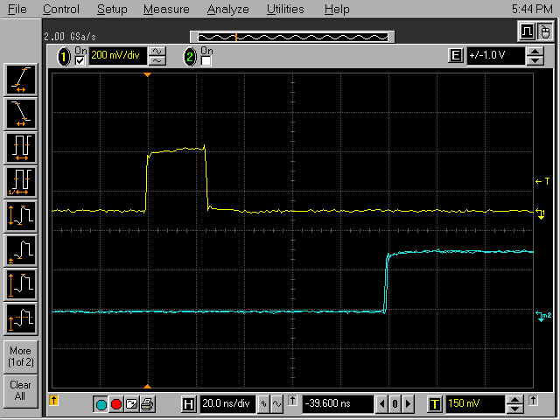
Figure 4.1 Identical timing of the ORBIT signal in respect to the calibration L0 in Global and Stand-alone modes
Trace 1: Calibration L0 in Global and Stand-alone modes; LTUvi board, ScopeProbe - channel B, selection code 4
Trace m1/m2: Front edge of the ORBIT pulse (1µs wide) in Global and Stand-alone modes; LTUvi board, ScopeProbe - channel A, selection code 1
Mandatory Rule 4.1:
The setting of ORBIT_BC register on the LTU board must always "track" the setting of BC_OFFSET register on the L0 board:
[ORBIT_BC] = ([BC_OFFSET] - 4) _{modulo 3564} [4.1]

Example: Since the new TTC Machine Interface (TTCmi) can provide a programmable delay of the ORBIT input to the BUSY board, it is likely that the BC_OFFSET on the L0 board shall always be 0; the corresponding setting of the ORBIT_BC, according to Formula 4.1, is 3560. With those settings, the delay between the calibration L0 (always in the bunch crossing 3556: [CALIBRATION_BC] = 3556 - LTU board; [TC_SET D[11..0]] = 3556 - L0 board) and the front edge of the ORBIT pulse (1µs wide) is the same in both Global and Stand-alone modes. This is shown in Figure 4.1.

5 Setting of the Prepulse lead time T_{ppl0} - PP_TIME register
Definition: The Prepulse signal is transmitted via the TTC Channel B as a broadcast command with the priority set to 1 (there are 5 priority levels, 0 to 4; 0 is the highest priority - see [3], section N.2.1); all the six user-bits D[7..2] are asserted (the bits are cleared in all other applications). At the output of TTCrx chip, the Prepalse is decoded as a coincidence of the Broadcast Strobe (BrcstStr1 or BrcstStr2) and any of the asserted user-bits D[7..2].
It is appropriate, therefore, to define the Prepulse-to-Calibration L0 time (T_{ppl0}) as the time between the corresponding Broadcast Strobe (BrcstStr1 or BrcstStr2) and the calibration L0 at the TTCrx output L1Accept - the "L0 over TTC" option. Providing that all the TTCrx coarse and fine delays are set to 0 and that the decoding of Prepulse and L0 adds symmetrical delays in both channels, the following Formula 5.1 gives an exact T_{ppl0} value for the "L0 over TTC" option; for any deviation from those default conditions; the result has to be appropriately corrected. A more serious deviation is likely in case of the "L0 over cable" option; even then the correction could be calculated - at least approximately (for details see section 8), but the proper value is best found experimentally.
With harmonised settings of ORBIT_BC and BC_OFFSET (section 4), the setting of the PP_TIME for a desired lead time T_{ppl0} (expressed in BCs) of the Prepulse in respect to the calibration trigger L0 is defined by the following formula:
[PP_TIME] = [CALIBRATION_BC] - 66 - T_{ppl0} [5.1]
Since the CALIBRATION_BC is always 3556, the formula can be simplified:
[PP_TIME] = 3490 - T_{ppl0} [5.2]
The set timing is equally valid in both Global and Stand-alone modes.
Example: For a desired T_{ppl0} of 80 BCs (~ 2µs), the corresponding setting is
[PP_TIME]_{2µs} = 3410
Verification: Figure 5.1 shows the TTCrx outputs involved in decoding of Prepulse, and their timing for two different settings of the PP_TIME register; the signals have been generated on the TTCrx test board.
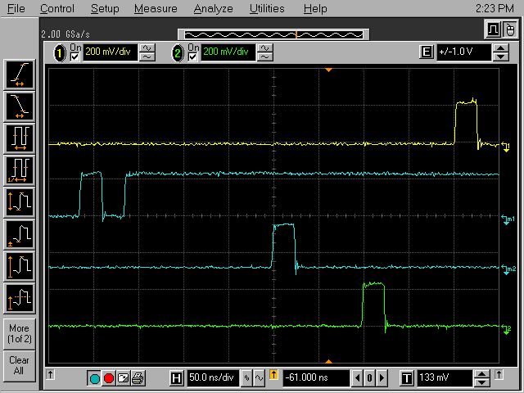
Figure 5.1 Prepulse to L0 delay at the TTCrx output for two different settings of the PP_TIME register: 3482 and 3486
Trace 1: Calibration L0 signal - TTCrx output L1Accept ("L0 over TTC" option).
Trace m1: Last few serial bits of the Prepulse broadcast command - TTCrx output
Serial_B_Channel; [PP_TIME] = 3482.
Trace m2: Data strobe of the Prepulse broadcast command - TTCrx BrcstStr1 output;
[PP_TIME] = 3482; the T_{ppl0} time is 8 BCs (200ns) - in full agreement with
Formula 5.1/5.2.
Trace 2: Data strobe of the Prepulse broadcast command - TTCrx BrcstStr1 output;
[PP_TIME] is increased to 3486; the corresponding T_{ppl0} time is 4 BCs (100ns).

Verification: Figure 5.2 depicts the measurement of the T_{ppl0} for [PP_TIME]_{2µs} = 3410; the delay of 1.9995 µs is indeed exactly 80 periods of the 40.079 MHz BC clock.

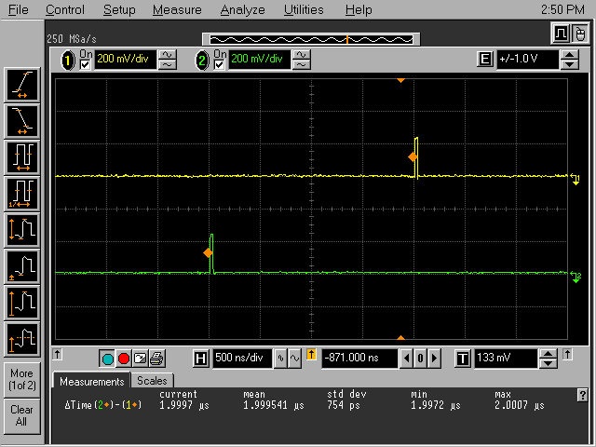
Figure 5.2 Prepulse to L0 delay of 2µs measured at the TTCrx output; [PP_TIME]=3410
Trace 1: Calibration L0 signal - TTCrx output L1Accept ("L0 over TTC" option).
Trace 2: Data strobe of the Prepulse broadcast command - TTCrx BrcstStr1 output;
[PP_TIME] = 3410.

6 Correction of the Mini ID mismatch - ORBIT_TIME register
In the trigger/DAQ jargon, the Mini ID is the event bunch crossing number read from the TTCrx BC counter at the time of arrival of the L1 trigger signal. The value should be identical to the event BC number contained in the L2a Message, but the DAQ tolerates the difference as long as it remains the same throughout the run. The difference - the mismatch - can be reduced to zero by adjusting the content of the ORBIT_TIME register (LTU board).
The correction tracks the setting of L1 time (DELAY_L0 on the L1 board; L1_DELAY on the LTU board); normally, its value is close to the current setting of the L0-to-L1 time (in BCs); the exact value - the setting that brings the mismatch to zero - needs to be found experimentally. The correction holds in both Global and Stand-alone modes.
Apart from the mismatch correction, the content of the ORBIT_TIME does not affect any other time setting - the mismatch correction is its only application.

7 TTCex interface - BC_DELAY_ADD and TTC_INTERFACE registers
The set-up time (t_{su}) and the hold time (t_{h}) requirements for the Channel A and Channel B signals are "mapped" to the A and B inputs of the TTCex board; they are defined in respect to the negative and the positive edge, respectfully, of the clock output CLK. The following values are quoted in the board's documentation [4]:
t_{su} = 5.1ns
t_{h} = 3.4ns
The values appear excessive since the board employs high-speed circuits. A closer inspection of the board schematics, taking into account the ICs' timing specs, reveals that the given values include - and justifiably so - a "healthy" safety margin of approximately 4ns; the details of the time analysis are presented in Figure 7.1.
The phase of the Chanel A/Channel B inputs depends upon the wiring of the TTC partition (cable length) and the content of the BC_DELAY_ADD register. The wiring in the ALICE experimental cavern is identical for all sub-detectors - see [3], Figure B; the scheme is also used for the test systems in the Trigger Lab; the wiring of test setups in collaboration home institutes should be done in the same way. The phase measurement performed on any of those systems should produce identical results and the conclusions are applicable to all.
Measurements of the phase of the input A/B in respect to the CLK output as a function of the BC_DELAY_ADD setting have been done on two test setups in the trigger lab, code-named "HMPID" and "MUON"; the measurements have been repeated on two systems in order to verify the consistency; the results are presented in Table 7.1. The phase difference has been measured using scope-probes connected directly to the TTCex inputs/outputs via a LEMO "Y" adapter; a typical scope display is shown in Figure 7.2. Positive values in Table 7.1 refer to the phase/time to the next corresponding (positive or negative) clock edge - a check of potential set-up time violation; negative values are the phase in respect to the preceding clock edge - a check of potential hold time violation. The measurements have been done only for settings around the time violation area (5.1ns/-3.4ns), in the no delay and the delay modes (the delay of ½BC option for Channel A/Channel B input is controlled by data bits D[0..1] of the TTC_INTERFACE word - [3], section M.2).

Figure 7.1 Evaluation of the set-up time (t_{su}) and the hold time (t_{h}) requirements for Channel A and Channel B inputs of the TTCex board.
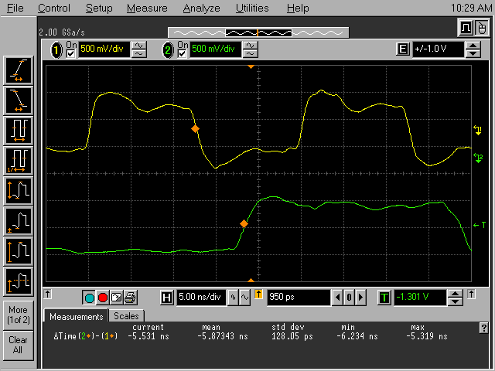
Figure 7.2 Typical measurement of phase of the TTCex input
[BC_DELAY_ADD] = 17; [TTC_INTRFACE] = 0
Trace 1: BC clock, TTCex output CLK1
Trace 2: Channel A input of the TTCex board

The measurements shown in Table 7.1 justify the selection of the delay/no delay option (TTC_INERFACE word) for the Channel A (data bit D[0]) and the Channel B (data bit D[1]) signals as a function of the BC_DELAY_ADD content; the appropriate settings are shown in the right-most column; for software applications, the cleaned-up version is reproduced as Table 7.2.
Mandatory Rule 7.1:
Following the LTU synchronisation procedure, define - Formula 3.1 - the setting of BC_DELAY_ADD word (0 to 31, but values higher than 25/26 should never be required); set the data bits D[1..0] of TTC_INTERFACE word according to Table 7.2; assert the data bit D[3] if the sub-detector uses the"L0 over TTC" option (bit D[2] is not used - don't care state).
Results of a recent synchronisation (Anton Jusko, 22.07.2008) of all ALICE TTC partitions are shown in Table 7.3 - BC delay (measured), together with the corresponding contents of the BC_DELAY_ADD word - BC delay (setting) - and the TTC_INTERFACE word. Those setting are currently used by the ALICE trigger system configuration software.
Table 7.1 Phase measurements of the Channel A and Channel B inputs (TTCex board) in the ALICE TTC partition
BC Delay | Channel A |  |  |  | Channel B |  |  |  | TTC Interface
BC Delay | No delay D[0]=0 |  | Delay D[0]=1 |  | No delay D[1]=0 |  | Delay D[1]=1 |  | TTC Interface
D[4..0] | "HMPID" | "MUON" | "HMPID" | "MUON" | "HMPID" | "MUON" | "HMPID" | "MUON" | D[1..0]
0 |  |  | 1.79ns | 1.39ns | 1.89ns | 1.85ns |  |  | 10
1 |  |  | 0.33ns | -0.02ns | 0.59ns | 0.34ns |  |  | 10
2 |  |  |  |  |  |  |  |  | 10
3 |  |  |  |  |  |  |  |  | 10
4 |  |  | -2.43ns | -2.96ns | -2.51ns | -2.73ns |  |  | 10
5 | 7.92ns | 7.28ns | -3.40ns | -4.09ns | -3.33ns | -3.36ns |  |  | 10
6 | 7.38ns | 6.65ns | -4.01ns | -4.79ns | -3.84ns | -3.95ns | 8.99ns | 8.51ns | 10
7 | 6.10ns | 5.81ns | -5.35ns | -5.64ns | -4.99ns | -4.95ns | 7.74ns | 7.63ns | 11
8 | 4.90ns | 4.80ns | -6.47ns | -6.46ns | -6.13ns | -5.72ns | 6.45ns | 6.89ns | 01
9 | 3.42ns | 3.15ns |  |  |  |  | 5.17ns | 5.61ns | 01
10 |  |  |  |  |  |  | 4.50ns | 4.61ns | 01
11 |  |  |  |  |  |  | 3.45ns | 3.65ns | 01
12 |  |  |  |  |  |  |  |  | 01
13 |  |  |  |  |  |  |  |  | 01
14 |  |  |  |  |  |  |  |  | 01
15 | -1.79ns | -1.71ns |  |  |  |  |  |  | 01
16 | -2.49ns | -2.73ns |  |  |  |  |  |  | 01
17 | -3.85ns | -4.32ns |  |  |  |  | -2.12ns | -2.19ns | 01
18 | -4.73ns | -5.30ns | 8.93ns | 8.47ns |  |  | -2.89ns | -2.93ns | 01
19 | -6.01ns | -6.56ns | 7.91ns | 7.61ns | 7.98ns | 7.65ns | -4.02ns | -3.78ns | 00
20 |  |  | 7.00ns | 6.59ns | 6.84ns | 6.66ns | -4.87ns | -4.94ns | 10
21 |  |  | 6.21ns | 5.69ns | 5.99ns | 5.93ns | -5.73ns | -5.76ns | 10
22 |  |  | 5.58ns | 5.04ns | 5.52ns | 5.40ns |  |  | 10
23 |  |  | 4.26ns | 3.94ns | 4.49ns | 4.50ns |  |  | 10
24 |  |  | 3.56ns | 3.15ns | 3.89ns | 3.85ns |  |  | 10
25 |  |  |  |  |  |  |  |  | 10
26 |  |  |  |  |  |  |  |  | 10
27 |  |  |  |  |  |  |  |  | 10
28 |  |  |  |  |  |  |  |  | 10
29 |  |  |  |  |  |  |  |  | 10
30 | 9.15ns |  |  |  |  |  |  |  | 10
31 | 8.10ns |  |  |  |  |  | 10.04ns | 9.99ns | 10

Table 7.2 Setting of the TTC_INTERFACE register as a function of the selected content of the BC_DELAY_ADD word
BC Delay | TTC Interface
D[4..0] | D[1..0]
0 | 10
1 | 10
2 | 10
3 | 10
4 | 10
5 | 10
6 | 10
7 | 11
8 | 01
9 | 01
10 | 01
11 | 01
12 | 01
13 | 01
14 | 01
15 | 01
16 | 01
17 | 01
18 | 01
19 | 00
20 | 10
21 | 10
22 | 10
23 | 10
24 | 10
25 | 10
26 | 10
27 | 10
28 | 10
29 | 10
30 | 10
31 | 10

Table 7.3 Current setting of the BC_DELAY_ADD and the TTC_INTERFACE registers in ALICE TTC partitions
Mnemonic | BC delay  (measured) | BC delay  (setting) | L0 over TTC | TTC interface  D[3..0]
SDD | 1 | 24 | + | 1x10 A
MCH | 1 | 24 |  | 0x10 2
MTR | 4 | 2 |  | 0x10 2
DAQ | 3 | 1 | + | 1x10 A
SPD | 4 | 2 | + | 1x10 A
TOF | 6 | 4 | + | 1x10 A
V0 | 4 | 2 | + | 1x10 A
TRD | 8 | 6 | + | 1x10 A
ZDC | 7 | 5 |  | 0x10 2
EMC | 10 | 8 | + | 1x01 9
TPC | 11 | 9 | + | 1x01 9
PMD | 12 | 10 |  | 0x01 1
ACORDE | 10 | 8 | + | 1x01 9
SSD | 8 | 6 |  | 0x10 2
FMD | 8 | 6 | + | 1x10 A
T0 | 7 | 5 | + | 1x10 A
HMPID | 12 | 10 |  | 0x01 1
PHOS | 12 | 10 | + | 1x01 9
CPV | 10 | 8 |  | 0x01 1

8 Definition of the L1 time (T_{L1}) - setting of the L1_DELAY register
Although a general meaning of the L1 time is well understood, a check/a verification of it in different applications is likely to produce inconsistent claims since the measurement procedure is not clearly defined; the ambiguity could cause misunderstandings. The following definition is an attempt to provide a uniform approach: for a given setting, the correct value of the T_{L1} is a time/a delay between the L0 and the L1 pulses at the L1Accept output of the TTCrx chip. The same delay can be measured at the Channel A output of the LTU board - front panel connector L1; or, more conveniently, at the ScopeProbe outputs A (selection code 20) or B (code 5). A typical scope display is shown in Figure 8.1.
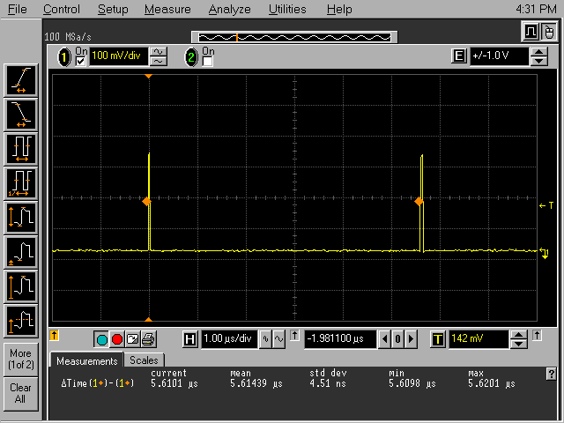
Figure 8.1 Measurement of the L0 to L1 delay (T_{L1}) - "L0 over TTC" option
[L1_DELAY] = 244 (LTU board, Stand-alone mode)
[DELAY_L0] = 170 (L1 board, Global mode)
Trace 1: Channel A (ScopeProbe output B, selection code 5)
The following formulae give the setting of the L1_DELAY (LTU board, Stand-alone mode) and the DELAY_L0 registers (L1 board, Global mode) for a desired value of T_{L1} (in BCs):
[DELAY_L0] = T_{L1} - 55 [8.1]
[L1_DELAY] = T_{L1} - 1 [8.2]
or, to harmonise the settings:
[L1_DELAY] = [DELAY_L0] + 54 [8.3]
Mandatory Rule 8.1:
In order to have identical timing in Global and Stand-alone modes, the setting of the L1_DELAY (LTU board) and the DELAY_L0 (L1 board) registers should always be harmonised - set for the same value of T_{L1}.
Example: The harmonisation at work is demonstrated in Figure 8.1: with [L1_DELAY] = 224 and [DELAY_L0] = 170, the value of T_{L1} = 225 BCs (5.614µs) is measured in both Global and Stand-alone modes.
A general T_{L1} definition is only possible for the "L0 over TTC" option; in the "L0 over cable" case, the L0 and the L1 signals are transmitted over different media: over the cable (4.5ns/m propagation delay for the standard ALICE LVDS cable) and over the TTC optical link (4.9ns/m propagation delay of the single mode 1310nm fibre and ~ 100ns delay for the TTCex set-up time margin, the TTCex encoding and the TTCrx decoding logic - Figure 8.2). The "individual correction" for the "L0 over cable" option is dependent upon the layout - the length of the cable, the length of the fibre, etc. ; for a given layout, the correction is constant, it could be estimated by a calculation, but the only place it can be verified is sub-detector's front-end.
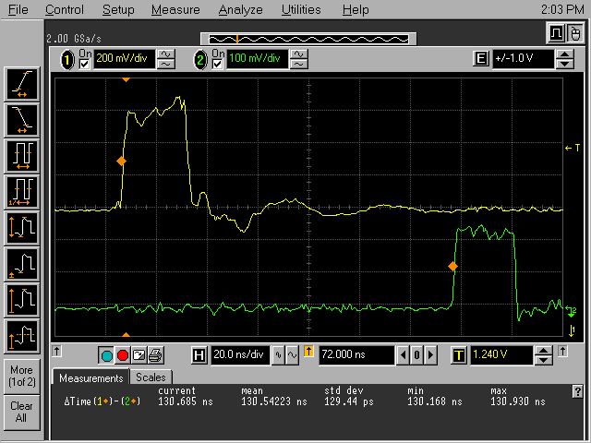
Figure 8.2 Measurement of the L0/L1 propagation delay over the TTC optical link
[BC_DELAY] = 4 - ~9ns set-up time to negative clock edge
TTC_NTERFACE D[0] = 0 - no Channel A delay
Trace 1: L0 output at the L0 connector of LTU board
Trace 2: L0 signal at the L1Accept pin of TTCrx chip

Figure 8.2 shows the measurement of skew between the L0 signal at the L0 output of the LTU board and the corresponding L0 at the L1Accept pin of the TTCrx chip. The waveforms have been sampled with identical scope-probes; the length of the optical-fibre between the TTCex board and the TTCrx chip is 5m (24.5ns); the setting of [BC_DELAY] is 4, without Channel A delay (TTC_NTERFACE D[0] = 0), gives ~9ns of set-up time in respect to the next negative edge of the TTCex clock (Table 7.1) - which is close to a practical minimum. After the subtraction of the optical-fibre delay (5m, 24.5ns), the remaining 106ns represent the "overhead" introduced by the Channel A signal encoding on the TTCex board and the signal decoding performed by the TTCrx logic. Identical delay is encountered by the L1 signal.

9 Definition of the L1-to-L2 time (T_{L1L2}) - setting of the L2_DELAY register
Seen from sub-detector's side, the timing of the L2 trigger is not very precise: both the L2a Message and the L2r Word are transmitted via the TTC's Channel B; both are subject to queuing, delays, priority arbitration etc. In order to make the setting measurable and its verification possible, the definition of the L2 time has to be "moved" to the LTU's internal logic, ahead of the uncertainty of the Channel B transmission delay. The following definition offers a convenient compromise.
The L1-to-L2 time T_{L1L2} is the delay between the L1 Strobe and the L2 Strobe signals inside the LTU Logic FPGA.
Both signals can be conveniently observed at the LTU's ScopeProbe outputs:
- L1 Strobe, output A, selection code 3
- L2a Strobe, output B, code 4 (coincides in time with more general L2 Strobe, output A, code 4)
In Global mode, the T_{L1L2} time is set by the CTP word DELAY_L1 (L2 board); in Stand-alone mode, on the other hand, the L2_DELAY word (LTU board) sets the L0-to-L2 time (T_{L2}), while the L0-to-L1 time (T_{L1}), is set separately by the L1_DELAY word.The difference makes the harmonisation formula somewhat more complicated:
[DELAY_L0] = T_{L1} - 55 [8.1]
[DELAY_L1] = T_{L1L2} - 64 [9.1]
[L2_DELAY] = T_{L1} + T_{L1L2} = T_{L2} [9.2]
or, in order to harmonise:
[L2_DELAY] = [DELAY_L0] + [DELAY_L1] + 119 [9.3]
Providing that the L1_DELAY setting has already been harmonised (Formula 8.2 or 8.3), Formula 9.3 assures in Stand-alone mode a value for T_{L1L2} identical to the one in Global mode.
Example: For T_{L1} = 225 BCs and T_{L1L2} = 3735 BCs, the corresponding settings for timing in Global mode would be:
[DELAY_L0] = T_{L1} - 55 = 170;
[DELAY_L1] = T_{L1L2} - 64 = 3671.
The harmonised settings in Stand-alone mode would be:
[L1_DELAY] = [DELAY_L0] + 54 = 224;
[L2_DELAY] = [DELAY_L0] + [DELAY_L1] + 119 = 3960.
Note: In the unlikely case that the full range of DELAY_L0 (9 bits) and of DELAY_L1 (12 bits) were used in Global mode, the range of the L2_DELAY (12 BITS) is not enough to enable harmonised emulation in Stand-alone mode. Just a comment…

10 Current setting of essential LTU timing-control words
The settings of all LTU words listed in Table 10.1 are essential - otherwise the timing in TTC partition is likely to become unpredictable and certainly different from expected; the given formulae could produce wrong results.
Table 10.1 Current setting of essential LTU timing-control words
Control word | Section | Setting | Comment
L1_DELAY | 8 | 224 | L0 to L1 time: 225 BCs
L2_DELAY | 9 | 3960 | L0 to L2 time: 3960 BCs
BC_DELAY_ADD | 3,7 | Sub-detector specific | Use Table 7.3
TTC_INTERFACE | 7 | Sub-detector specific | Use Table 7.3
ORBIT_TIME | 6 | Sub-detector specific | Correct CDH mismatch
PP_TIME | 5 | Sub-detector specific | Use Formula 5.1 or 5.2
LAST_BC |  | 3563 | System parameter
PREPULSE_BC |  | 128 | System parameter
CALIBRATION_BC |  | 3556 | System parameter
GAP_BC |  | 3446 | System parameter
ORBIT_BC |  | 3560 | System parameter
The settings should also be used in test systems in home institutes in order to correctly emulate the application timing; this is particularly relevant for sub-detectors with "L0 over cable" option.

References

[1] LTU - Preliminary Design Review, Revision 1.0 [6]
[2] LTU - Software Model, Revision 0.1 [6]
[3] LTUvi - Software Model Update [6]
[4] TTC Laser Transmitter (TTCex, TTCtx, TTCmx) User Manual, TTC web site:
http://ttc.web.cern.ch/ttc/
[5] Proposal to Transmit L0 signal over TTC optical Link [6]
[6] ALICE Trigger web site: ALICE-Projects-Trigger, or directly:
http://epweb2.ph.bham.ac.uk/user/pedja/alice/

